April 2018

Dear Sir / Madam,

I am enclosing here my Resume for your kind consideration and hope that my experience and qualifications will be suitable for the vacant post at your esteemed Organization.

Currently I am working at a APM Terminal as a Warehouse Controller, ensuring all items receieved are in an adequet manner with the proper quality and condition. My high level of concentration and dedication has helped me manage multiple tasks within a fast paced envoirment.

I am seeking an opportunity to be part of a professional organization in which I can achieve my goals and work as a team member to attain the goals of the organization. As well as improving my skills and gaining the experience that will help me perform at the highest levels to satisfy the requirements of the organization and my personal fulfillment.

Looking forward to hearing from you soon.

Yours Sincerely,

Noor .S. Mohammed

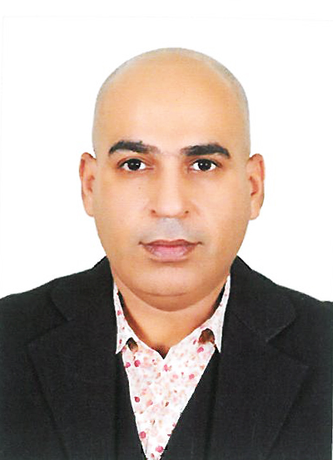
Noor Mohammed Sharif
Nationality: Bahraini
CPR#: 741205220
Marital Status: Married
Phone: + 973 36681140, + 973 38370622

Email: KtmNoorie@Hotmail.com,

KtmNoorie@Gmail.com

Educational Background

Bsc. In (XXX), (19XX)

University of Bahrain, kingdom of Bahrain

GCE (AS ) From university of Cambridge

IGCSE From university of Cambridge from ( 2007 ) to ( 2008 ).

Professional Qualificatoins and Training
- First Diploma in motor vehicle technology from Bahrain Training Institute (2003)
- Diploma in I.T (Information Technology) from Delmon Academy Bahrain (1995)
- Certificate in First Aid Course Life Support skills (1997)
- First Aid CPR Basic Life Support skills (Approved Oman Educational Department) from Khaleej Oman Institute LLC (1999)
- Certificate in Human Performance Improvement

Professional Experience

APM Terminal (January 2015 till Present)

Warehouse Controller – Operatoins Department:
- Maintain records of all issues and locations of inventoy items
- Receive parts, inspect all materials received for proper quality, condition and documentation according to purchase orders
- Arrange for parts shipments to accomplish stock transfer
- Communicate and implement company policies and procedures and follow up to ensure compliance.
- Ensure all health and safety guidelines are enforced and and concerens resolved
- Ensure housekeeping standards and equipment maintenance 7
- Other duties assigned by Manageent

Bahrain Workshop Company W.L.L (December 2013 – December 2014)

Clearing Clerk:
- effective working relationship with Customers, Customs
- Maintain a safe work enviroment.
- Maintain and insure Cargo unstaffed safly and dilivered to customers

Bahrain International Airport (April to September 2007)

Tools Store Supervisor:
- Doing purchasing job and buying special Tools for aircrafts.
- Ordering parts from Switzerland and Receiving special parts for Aircraft’s.
- Using computer system for Tools Store and for Aircraft’s.

Additional Skills:
- Very good knowledge of Microsoft Office package (Word, Excel, Powerpoint)
- Fluent speaking and writing in Arabic and English

Referenes:
Upon request

